3GPP TSG RAN WG1 #120 R1-2500067
Athens, Greece, February 17th–21st, 2025
Title: Discussion on AI/ML-based positioning enhancement
Source: ZTE Corporation, Pengcheng Laboratory
Agenda item: 9.1.2
Document for: Discussion/Decision

Introduction
In RAN1#119 meeting, the following conclusion and agreements [1] were achieved for Artificial Intelligence (AI)/Machine Learning (ML) positioning accuracy enhancement:
Conclusion
For measurement report of AI/ML assisted positioning Case 3a, regarding the report of LOS/NLOS indicator,
- LOS/NLOS indicator can’t be reported independently from other measurements

Agreement
For the definition of sample-based measurement, for gNB/TRP measurement of an estimated channel response between a pair of UE and TRP, the starting time of the list of N_{t} consecutive samples is determined as follows.
  - starting time = first detected path rounded down with timing granularity T.
Note: UE-side measurement is a separate discussion

Agreement
For model performance monitoring of AI/ML positioning Case 1, support at least:
- Option A. The target UE side performs monitoring metric calculation.
  - The target UE may signal the monitoring outcome to the LMF.
  - FFS: content of monitoring outcome
- FFS: Option B

Agreement
For Rel-19 AI/ML based positioning, for Case 3b, in addition to path-based measurement that is referring to the measurement in the existing specifications (up to Rel-18), additionally support the following enhancement to the measurement,
- The measurement is composed of N_{t}' values of the estimated channel response in time domain. The N_{t}’ values are selected from a list of N_{t} consecutive channel response values, which have timing granularity T.
- The timing information for the N_{t}' values are reported with a timing granularity T, where T=2^{k}xT_{c}. k represents the timing reporting granularity factor. T_{c} is the basic time unit for NR.
  - The associated measurement (e.g., power if reported) corresponds to the measurement for the reported N_{t}' values.
- The timing information is defined relative to a reference time, same as the path-based measurement.
- The N_{t}’ selected time domain channel measurement values are expected to be those with the highest power.
- The starting time of the list of N_{t} consecutive values is determined as: starting time = first detected path rounded down with timing granularity T.
- LMF can signal parameter values of N_{t}, N_{t}', k to gNB via NRPPa. Candidate set values:
  - N_{t}'<=24. FFS: N_{t}' values.
  - N_{t} = {32, 64, 128}
  - FFS: k
  - The gNB/TRP may use different N_{t}', N_{t} and/or k values other than the signalled parameter for measurement reporting. In this case, it’s up to LMF implementation to process the reported measurement
- FFS: whether transmit offset from gNB to LMF
Note: measurement by UE is a separate discussion.
Note: the purpose of the time domain channel measurements, such as for Rel-19 AI/ML based positioning, is not specified

Agreement
For AI/ML based positioning Case 1, all assistance information from legacy UE-based DL-TDOA, other than info #7, can be provided from LMF to UE. For info #7, RAN1 study, if necessary, choose one alternative from the following:
- Alternative 1. Info #7 is provided implicitly via associated ID.
  - Associated ID is signaled by LMF to indicate whether info #7 is consistent between training and inference.
- Alternative 2. Info #7 can be provided either implicitly or explicitly by LMF. Note: no UE capability is introduced on whether info #7 is provided implicitly or explicitly, and the UE can request info #7 to be provided explicitly or implicitly.
  - If provided implicitly, associated ID is signaled by LMF to indicate whether info #7 is consistent between training and inference.
- Alternative 3. Info #7 is not be provided from LMF to UE.
  - If info #7 is not provided, UE may assume info #7 is consistent between training and inference.
- Alternative 4. Info #7 is provided explicitly from LMF to UE.
7 | Geographical coordinates of the TRPs served by the gNB (include a transmission reference location for each DL-PRS Resource ID, reference location for the transmitting antenna of the reference TRP, relative locations for transmitting antennas of other TRPs)

Several future discussion points for AI/ML positioning are listed in [2] based on the discussion in RAN1#119. In this contribution, we provide our views on the potential specification impacts for positioning accuracy enhancement with AI/ML.

Use cases

Supported use cases
During the Rel-18 study, RAN1 discussed various use cases for AI/ML positioning, and WID specified different priorities for the studied use cases. In Table 1, we summarized the detailed procedure for model training and model inference process of AI/ML positioning.
The WID on AI/ML for NR air interface specified different priorities for the studied use cases in AI/ML positioning:
- 1st priority use cases:
  - Direct AI/ML positioning:
    - Case 1: UE-based positioning with UE-side model, direct AI/ML positioning
    - Case 3b: NG-RAN node assisted positioning with LMF-side model, direct AI/ML positioning
  - AI/ML assisted positioning:
    - Case 3a: NG-RAN node assisted positioning with gNB-side model, AI/ML assisted positioning
- 2nd priority use cases:
  - Direct AI/ML positioning:
    - Case 2b: UE-assisted/LMF-based positioning with LMF-side model, direct AI/ML positioning
  - AI/ML assisted positioning:
    - Case 2a: UE-assisted/LMF-based positioning with UE-side model, AI/ML assisted positioning
Table 1 Summary of the use cases discussed for AI/ML positioning
1st priority use cases | Case 1: UE-based positioning with UE-side model, direct AI/ML positioning  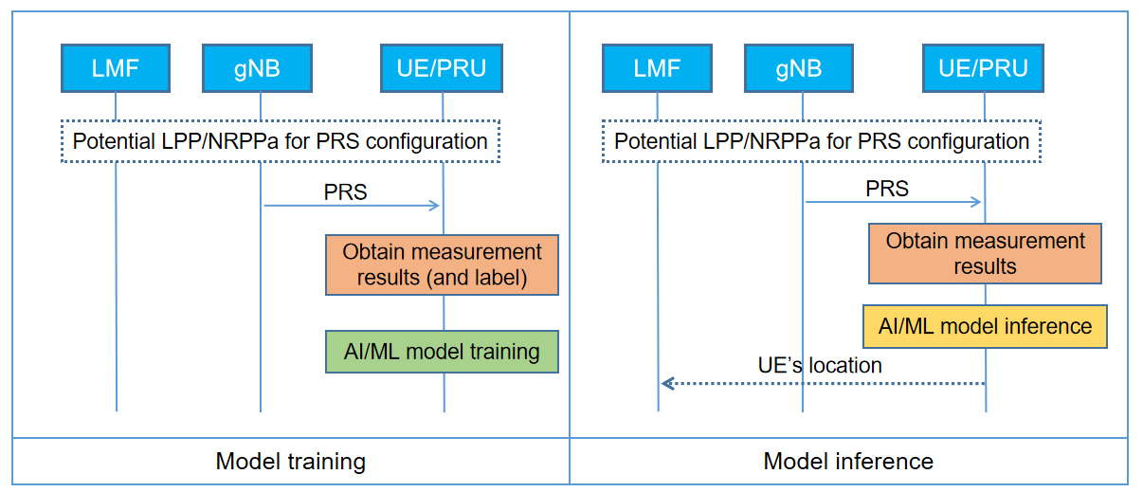
Case 3a: NG-RAN node assisted positioning with gNB-side model, AI/ML assisted positioning
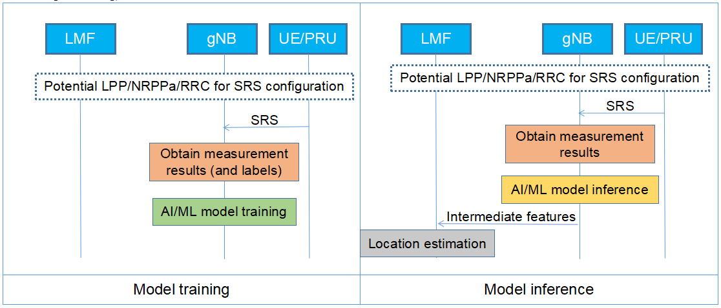
Case 3b: NG-RAN node assisted positioning with LMF-side model, direct AI/ML positioning
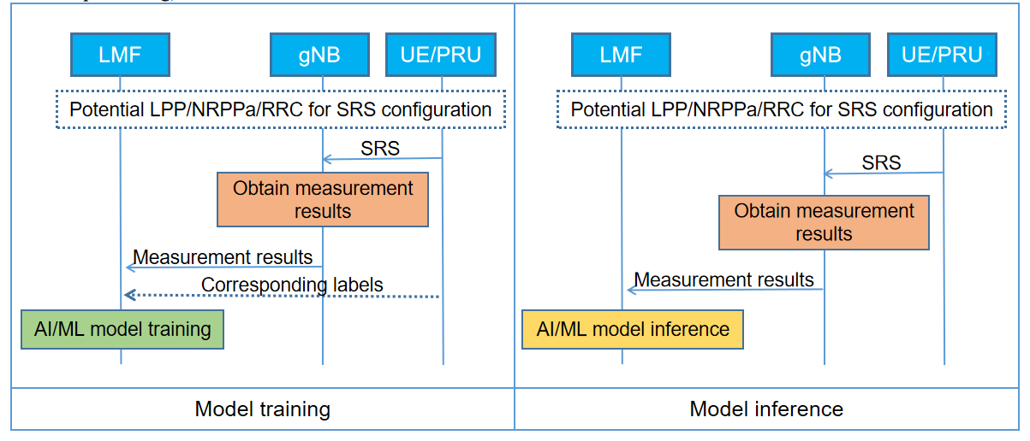
2nd priority use cases | Case 2b: UE-assisted/LMF-based positioning with LMF-side model, direct AI/ML positioning  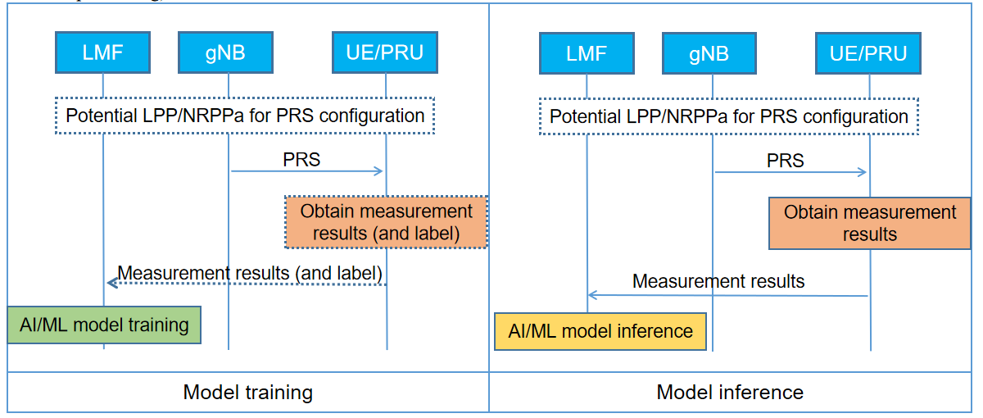
Case 2a: UE-assisted/LMF-based positioning with UE-side model, AI/ML assisted positioning
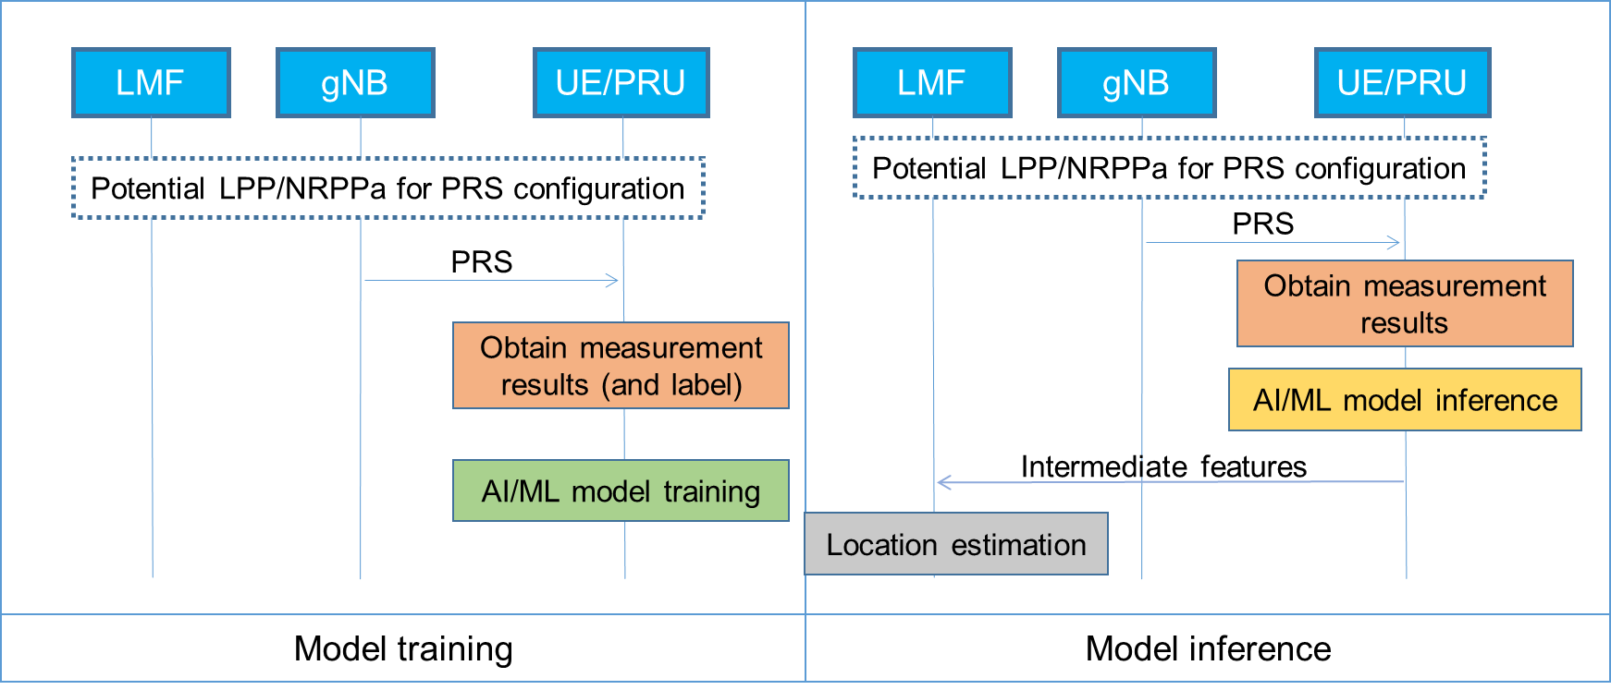

Combination of different use cases
In previous meeting, whether support combination of different use cases is intensively discussed. A consensus was reached that RAN1 will proceed with the investigation assuming each case is deployed individually, unless RAN plenary expand the scope of the WID to explicitly support certain combinations of different use cases. In the following discussion, we may proceed with the specification enhancements assuming each case is deployed individually.

Model input
In RAN1#119, the model input for case 3b is determined as follows:
Agreement in RAN1#119:
For Rel-19 AI/ML based positioning, for Case 3b, in addition to path-based measurement that is referring to the measurement in the existing specifications (up to Rel-18), additionally support the following enhancement to the measurement,
- The measurement is composed of N_{t}' values of the estimated channel response in time domain. The N_{t}’ values are selected from a list of N_{t} consecutive channel response values, which have timing granularity T.
- The timing information for the N_{t}' values are reported with a timing granularity T, where T=2^{k}xT_{c}. k represents the timing reporting granularity factor. T_{c} is the basic time unit for NR.
  - The associated measurement (e.g., power if reported) corresponds to the measurement for the reported N_{t}' values.
- The timing information is defined relative to a reference time, same as the path-based measurement.
- The N_{t}’ selected time domain channel measurement values are expected to be those with the highest power.
- The starting time of the list of N_{t} consecutive values is determined as: starting time = first detected path rounded down with timing granularity T.
- LMF can signal parameter values of N_{t}, N_{t}', k to gNB via NRPPa. Candidate set values:
  - N_{t}'<=24. FFS: N_{t}' values.
  - N_{t} = {32, 64, 128}
  - FFS: k
  - The gNB/TRP may use different N_{t}', N_{t} and/or k values other than the signalled parameter for measurement reporting. In this case, it’s up to LMF implementation to process the reported measurement
- FFS: whether transmit offset from gNB to LMF
Note: measurement by UE is a separate discussion.
Note: the purpose of the time domain channel measurements, such as for Rel-19 AI/ML based positioning, is not specified
The remaining issue concerning the model input includes the following aspects:
- Candidate values for N_{t}' and k (FFS in the agreement)
- Whether transmit offset from gNB to LMF (FFS in the agreement)
- Model input for case 2b (Note in the agreement)
In this section, we will discuss the above undetermined aspects.

Candidate values for N_{t}’ and k
The model input for case 3b attaches the features of sample-based measurement on top of path-based measurement. In the current positioning, the maximum number of additional measurements is 8:
Range bound | Explanation
maxNoPathExtended | Maximum no. of extended additional path measurement. Value is 8.
The range of the additional path item reported by TRP is 1~8, where the report of the additional path list and extended additional path list are optional, therefore, the total number of reported paths could be 1~9. For N_{t}', the number of reported values should be larger than or equal to the number of supported path reports, therefore, the candidate values for N_{t}' include {9, 16, 24}. And for candidate values for k, Rel-16 values can be supported.
For the candidate values for N_{t}' and k, we have the following proposal:
Proposal 1: The following candidate values for N_{t}' and k are supported:
- The set of candidate values for N_{t}' include at least: 9, 16, 24.
- The set of candidate values for k include at least: 0…5.

Whether transmit offset from gNB to LMF
A general reporting example is shown in Figure 1, where the reported values are selected from N_{t} consecutive values, and the starting time of the list of N_{t} consecutive values is determined as the first detected path rounded down with timing granularity T. And the reported N_{t}’ selected time domain channel measurement values are expected to be those with the highest power. From our perspective, the mentioned offset refers to the interval between the starting time of N_{t} and the first reported path. In the following example, the offset between the starting time of N_{t} and the first reported path is equal to 0.
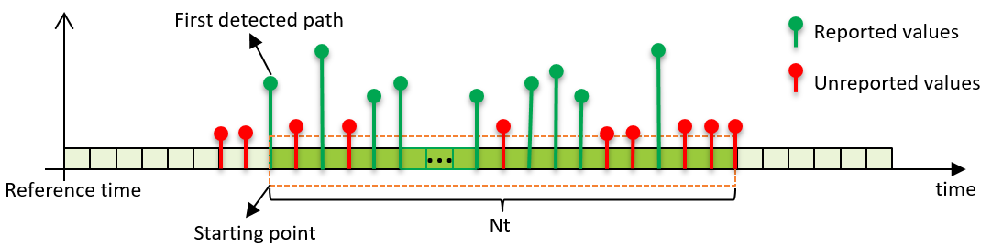
Figure 1 Channel measurement profile example #1: offset = 0
In another channel measurement profile, as shown in Figure 2, the first detected path may not be reported, where the first detected path is not within the N_{t}’ selected time domain channel measurement values with the highest power. In this example, offset between the starting time of N_{t} and first reported path is not equal to 0.
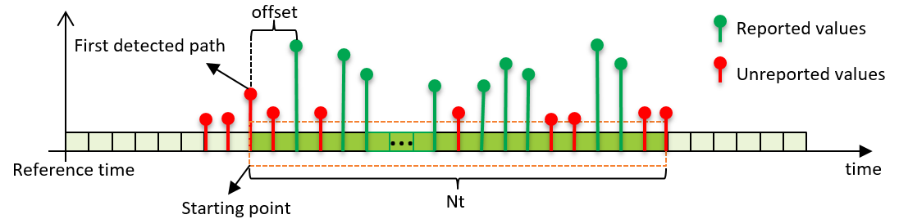
Figure 2 Channel measurement profile example #2: offset ≠ 0
The FFS left in the agreement concentrates on whether the offset between the starting time of N_{t} and the first selected path should be reported. From our perspective, the report of offset is not necessary, detailed reasons are as follows:
- The model input of AI/ML positioning model is the selected N_{t}’ values, the offset between the starting time of N_{t} and the first reported path doesn’t carry any channel information of the measured reference signal.
- The reported values are expressed relative to the reference time instead of relative to the starting point. With the reported values and time, LMF is aware of the explicit timing of each reported value.
- In most cases, the first detected path is reported, because first detected path is usually the path with higher power, i.e., the offset is generally equal to 0, reporting example #2 is a corner case. Furthermore, the report of offset between the starting time of Nt and first reported path may disclose the implementation of gNB.
Based on the above analysis, we have the following proposal:
Proposal 2: Do not support gNB report offset to LMF in AI/ML positioning case 3b.

Model input for case 2b
In previous meetings, model input for case 2b was discussed intensively, but there’s no agreement achieved. For case 2b, the model input can be defined with similar principle, where the intersection between gNB and UE report could be determined in the first stage. The model input for case 2b could support path-based measurement additionally support enhancement to the sample-based report, including:
- N_{t}’ values are selected from N_{t} consecutive channel response values.
- The timing information for N_{t}’ and N_{t} has timing granularity, where T=2^{k}xT_{c}. k represents the timing reporting granularity factor.
- The timing information is defined relative to a reference time. FFS: reference time.
- The starting time of the N_{t} consecutive values is determined as: starting time = first detected path rounded down with timing granularity T.
For the model input, we have the following proposal for case 2b:
Proposal 3: For Rel-19 AI/ML based positioning, for Case 2b, in addition to path-based measurement that is referring to the measurement in the existing specifications (up to Rel-18), additionally support the following enhancement to the measurement,
- The measurement is composed of N_{t}' values of the estimated channel response in time domain. The N_{t}’ values are selected from a list of N_{t} consecutive channel response values, which have timing granularity T.
- The timing information for the N_{t}' values are reported with a timing granularity T, where T=2^{k}xT_{c}. k represents the timing reporting granularity factor. T_{c} is the basic time unit for NR.
  - The associated measurement (e.g., power if reported) corresponds to the measurement for the reported N_{t}' values.
- The timing information is defined relative to a reference time, same as the path-based measurement.
- The starting time of the list of N_{t} consecutive values is determined as: starting time = first detected path rounded down with timing granularity T.
- LMF can signal parameter values of N_{t}, N_{t}', k to UE via LPP. FFS: Candidate set values.
  - The UE may use different N_{t}', N_{t} and/or k values other than the signalled parameter for measurement reporting. In this case, it’s up to LMF implementation to process the reported measurement.
Note: the purpose of the time domain channel measurements, such as for Rel-19 AI/ML based positioning, is not specified.

Definition of channel measurement quality
In RAN1#118bis, RAN1 agreed that the quality indicator of timing information in Part A should be reported.
Agreement in RAN1#118bis:
For training data collection of AI/ML based positioning, the quality indicator of timing information in Part A when reported is:
- When applicable, the existing IE for timing quality, i.e., NR-TimingQuality in 37.355 and IE “Timing Measurement Quality” in 38.455;
  - FFS: details on how to associate quality indicator to timing information
But the details are not determined yet, where the following aspects should be considered:
- Q1: whether both timing and power quality are provided if the channel measurement includes both timing information and power information
- Q2: the association between quality and measurement: quality refers to the whole channel measurement or refers to a values of channel measurement
For Q1, from our perspective, there’s no need to introduce power quality for channel measurement, where a single timing quality can reflect the whole measurement quality. Furthermore, there’s no power quality indicator defined in the current specification. For Q2, a quality indicator should be associated with the whole channel measurement, it’s difficult to define and estimate quality indicator for each reported value, a single indicator can represent the quality of the entire channel profile. Therefore, we have the following proposals:
Proposal 4: There’s no need to introduce power quality for channel measurement.
Proposal 5: For training data collection of AI/ML based positioning, the quality indicator of timing information in Part A is associated with the whole channel measurement.

Other aspects

Reference time for cases other than case 3b
In the last several meetings, the reference time for case 3b was agreed as follows:
Agreement in RAN1#116:
For AI/ML based positioning Case 3b, for gNB channel measurements reported to LMF, the timing information is represented relative to a reference time.
- FFS: Whether any specification impact of the reference time used to represent the timing information. Details of the reference time

Agreement in RAN1#116bis:
For AI/ML based positioning Case 3b, for gNB channel measurements reported to LMF, the timing information is represented relative to the existing UL RTOA reference time T₀+t_{SRS} as defined in TS 38.215.
FFS: whether it is applicable when Case 3b is used to support multi-RTT
For other use cases, the reference time for UE channel measurement report should be considered. In current legacy positioning methods, DL RSTD and UE Rx-TX time difference are introduced for measurement reports. For AI/ML based positioning case 2b, the reference time for channel measurement report can be the same as the Rx time of the reference TP and/or the Tx time for UE Rx-Tx time difference. However, RAN1 prefers proceeding with the investigation assuming each case is deployed individually, where multi-RTT positioning method is de-prioritized, therefore, we have the following proposal (the following proposal is related to 2nd priority use case, which can be discussed later):
Proposal 6: For AI/ML based positioning case 2b, for UE channel measurement reported to LMF, reuse the reference time of current DL RSTD and/or UE Rx-Tx time difference, the following options can be considered:
- Option 1 (1st priority): The reference time is T_{SubframeRxi}, as defined in TS 38.215, clause 5.1.29.
- Option 2 (2nd priority): The reference time is T_{UE-TX}, as defined in TS 38.215, clause 5.1.30.

Phase information as model input
In RAN1#116 meeting, DP and PDP are supported for case 2b and case 3b, but CIR is still undetermined. And in RAN1#117, the proposals below are discussed but without consensus:
Proposed conclusion 2.4.2-2 in RAN1#117:
For Rel-19 AI/ML based positioning for all use cases, there is no consensus in RAN1 to support CIR for determining model input.

Proposal 2.4.2-1 in RAN1#117:
For Rel-19 AI/ML based positioning for all use cases, in terms of using phase information (in addition to timing information and power information) for determining model input, do not support using one phase value (e.g., Rel-18 measurements DL RSCPD, DL RSCP, UL RSCP) for the first path or first sample only.
In the following, we will discuss the necessity and feasibility of CIR/phase information for AI/ML based positioning.

Tradeoff of positioning accuracy and signaling overhead
The signalling overhead of PDP and CIR are as follows:
The size of CIR can be calculated with
N'_{TRP} * N_{t} + N'_{TRP} * N_{port} * N_{t}’ * (B_{real,PDP} + B_{phase})
The size of PDP can be calculated with
N'_{TRP} * N_{t} + N'_{TRP} * N_{port} * N_{t}’ * B_{real,PDP}
where N'_{TRP} * N_{t} refers to a bitmap with N'_{TRP} rows and N_{t} columns to indicates the locations of the N'_{t} selected values for different TRPs.
The meanings of different elements are list as follows:
- N’_{TRP}: number of active TRPs that provide measurements for model input
- N_{t}: number of consecutive time domain values as model input
- N_{t}’: number of selected time domain values as model input
- N_{port}: number of antenna port pairs for model input
- B_{phase}: number of bits to represent a real value for phase
- B_{real,PDP}: number of bits to represent a real value for path power for PDP
Using the above equation, the signalling overhead of the above input as well as the performance of PDP/CIR evaluated in [3] is summarized in the following table:
Table 2 Tradeoff of positioning accuracy and signaling overhead for AI/ML positioning based on PDP/CIR
Model input | AI/ML complexity |  | Horizontal positioning accuracy at CDF=90% (meters) | Signalling overhead  (Gigabyte)
 | Model complexity | Computation complexity | AI/ML | AI/ML
PDP ${{\{N}_{port},N}_{TRP}, N_{t},N_{t}^{'}\}$= {1, 18, 256, 64} | 9.50 M | 158.47 M | 0.508 | 0.139
CIR ${{\{N}_{port},N}_{TRP}, N_{t},N_{t}^{'}\}$= {1, 18, 256, 64} | 9.50 M | 158.66 M | 0.421 | 0.263
PDP ${{\{N}_{port},N}_{TRP}, N_{t},N_{t}^{'}\}$= {1, 18, 256, 128} | 9.50 M | 158.47 M | 0.446 | 0.263
CIR ${{\{N}_{port},N}_{TRP}, N_{t},N_{t}^{'}\}$= {1, 18, 256, 128} | 9.50 M | 158.66 M | 0.278 | 0.510
PDP${{\{N}_{port},N}_{TRP}, N_{t},N_{t}^{'}\}$= {2, 18, 256, 256} | 9.50 M | 158.66 M | 0.369 | 1.004
CIR ${{\{N}_{port},N}_{TRP}, N_{t},N_{t}^{'}\}$= {2, 18, 256, 256} | 9.69 M | 172.77 M | 0.167 | 1.993
Based on the above simulation, we have the following observation:
Observation 1: The positioning performance of CIR based model input is better than PDP based model input, which shows that path phase information is beneficial for AI/ML based positioning, while the signalling overhead of CIR is slightly higher than that of PDP. Exemplary results are:
- For single port evaluation with N_{t}’ =64, the positioning error of PDP based positioning is about 1.20 times that of CIR based positioning, the overhead of CIR is about 1.89 times that of PDP;
- For single port evaluation with N_{t}’=128, the positioning error of PDP based positioning is about 1.60 times that of CIR base positioning, the overhead of CIR is about 1.94 times that of PDP;
- For multi-port evaluation with N_{t}’=256, the positioning error of PDP based positioning is about 2.21 times that of CIR base positioning, the overhead of CIR is about 1.98 times that of PDP.
It should be noted that the signalling overhead is evaluated without any overhead reduction methods, the overhead of CIR is less than twice that of PDP, while achieving better positioning performance. By comparing the third and second rows of the table, we can observe that CIR with N_{t}’=64 has the same overhead as PDP with N_{t}’=128, but CIR’s positioning performance is better than that of PDP.
Observation 2: Compared with PDP, CIR may provide better positioning performance when the signalling overheads of CIR and PDP are the same.

The impact of transmitter and receiver implementation
For a transmitted DL PRS/UL SRS, UE/TRP is able to demodulate the reference signal, where the channel measurement information contains two branch signal, i.e., real signal I(t) and imaginary signal Q(t). The phase information can be extracted with the received channel measurement information.

Specification impact
In AI/ML based positioning, timing information, paired timing and power information are supported for case 2b and case 3b. If CIR is supported for AI/ML based positioning, the phase information can be attached to the paired timing information and power information. Furthermore, carrier phase is supported for positioning purpose in Rel-18, and UE/TRP can report the phase information (UE reports RSCP/RSCPD, TRP reports RSCP) to LMF. Therefore, its’ feasible to use phase information for determining model input. Based on the above analysis, we have the following proposal:
Proposal 7: In AI/ML based positioning, phase information is used for determining model input.

Mapping table for power measurement
As agreed in previous meetings, power measurement information is supported as model input for AI/ML positioning, where each power measurement report is associated with a timing measurement. In current specification, RSRP or RSRPP is supported for TDOA, RTT, AOD, etc., where the maximum number of reporting paths is limited to a pre-defined value, i.e., 1 path and 8 additional paths.
In TS 38.215, DL PRS-RSRP is defined as:
DL PRS reference signal received power (DL PRS-RSRP), is defined as the linear average over the power contributions (in [W]) of the resource elements that carry DL PRS reference signals configured for RSRP measurements within the considered measurement frequency bandwidth.
DL PRS-RSRPP is defined as:
DL PRS reference signal received path power (DL PRS-RSRPP), is defined as the power of the linear average of the channel response at the i-th path delay of the resource elements that carry DL PRS signal configured for the measurement, where DL PRS-RSRPP for the 1st path delay is the power contribution corresponding to the first detected path in time.
For DL AI/ML positioning, the model input includes N_{t}’ values, power information refers to the power of each reported value, where the current definition of PRS-RSRPP can be a starting point. And in RAN1#118 meeting, the following proposal was agreed in terms of power definition:
Agreement in RAN1#118:
For AI/ML positioning Case 2b and 3b, regarding the power information for determining the model input,
- For downlink power measurement, use DL PRS-RSRPP defined in TS 38.215 as a starting point.
  - For measurement report of DL PRS-RSRPP, use the existing measurement report mapping table for PRS-RSRPP in 38.133 as a starting point.
- For uplink power measurement, use UL SRS-RSRPP defined in TS 38.215 as a starting point.
  - For measurement report of UL SRS-RSRPP, use the existing measurement report mapping table for SRS-RSRPP in 38.133 as a starting point.
For the mapping table in TS 38.133, the current measurement report range of RSRPP is defined from -156dBm to -31dBm with 1dB resolution. To evaluate the necessity of defining finer RSRPP report for AI/ML positioning, the following simulation is conducted:
Case 1: The power measurement is defined with 1dB resolution.
Case 2: The power measurement is defined with 0.5dB resolution.
The positioning performance (CDF of positioning error) of case 1 and case 2 are as follows:
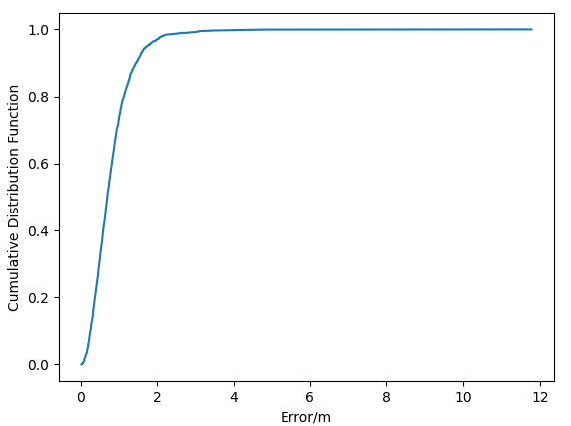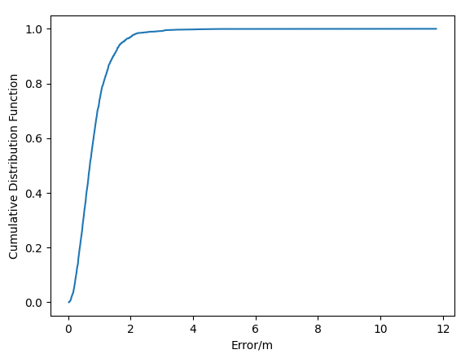
(a) Case 1: Positioning error @90%=0.90 m (b) Case 2: Positioning error @90%=0.84m
Figure 3 Positioning error of different power measurement resolutions
It can be observed that the positioning error of case 2 achieves only 6.67% performance gain while the report overhead is doubled. Based on the above analysis, we have the following observation:
Observation 3: For power measurement, the positioning performance of case 2 is slightly better than case 1 (6.67% performance gain), while the signalling overhead of case 2 is twice that of case 1.
Based on the observation, we have the following proposal:
Proposal 8: The mapping table of RSRPP in TS 38.133 can be reused for AI/ML positioning.

Model output

LOS/NLOS indicator
In RAN1#118bis meeting, the following proposals were discussed concerning LOS/NLOS indicator report in case 3a, but there’s no consensus reached:
Proposal 3.1.5-1
For AI/ML assisted positioning, when the LOS/NLOS indicator is reported for Rel-19 Case 3a, and the other associated measurement (e.g., timing information) is obtained by legacy positioning methods, from RAN1 perspective,
- The LOS/NLOS indicator provides the likelihood of a line-of-sight propagation path for the channel measured over the resource for which the measurement is reported;
- The LOS/NLOS indicator can reuse the existing IE "LoS/NLoS Information" in 38.455, which can be soft indicator or hard indicator.
- Note: it is up to RAN3 to decide how to differentiate a report for Rel-19 Case 3a from a report for pre- Rel-19 positioning.
FFS: whether LOS/NLOS indicator is reported when the associated timing information is generated by AI/ML, and if so, the meaning of the LOS/NLOS indicator.
In RAN1#119, it was agreed that the LOS/NLOS indicator cannot be reported independently from other measurement. The combinations of LOS/NLOS indicator and measurement include:
- Combination #1: Measurement from legacy positioning method, LOS/NLOS indicator from legacy positioning method. (already supported in the current specification)
- Combination #2: Measurement from legacy positioning method, LOS/NLOS indicator from AI/ML positioning. (possible enhancements)
- Combination #3: Measurement from AI/ML positioning, LOS/NLOS indicator from legacy positioning method. (Not expected to be supported in AI/ML positioning)
- Combination #4: Measurement from AI/ML positioning, LOS/NLOS indicator from AI/ML positioning. (possible enhancements)
Among the above combinations, enhancements for LOS/NLOS indicator include new LOS/NLOS indicator from AI/ML positioning, where measurement comes from legacy positioning method or AI/ML positioning. The meaning of LOS/NLOS indicator associated with the legacy positioning method is defined in current specification, while the meaning of LOS/NLOS indicator for AI/ML assisted positioning is still unclear now. As shown in the following figure, there are two possible explanations for the meaning of LOS/NLOS indicator:
- Explanation 1: LOS/NLOS indicator is associated with channel measurement, the meaning of LOS/NLOS indicator refers to the propagation path’s transmission. A combination of AI/ML output and legacy timing measurement for determining UE’s location is not workable. An extra indicator for model output is required.
- Explanation 2: LOS/NLOS indicator is associated with model output. If the timing measurement of the virtual LOS path, the indicator value of AI/ML model output should be equal to 1.

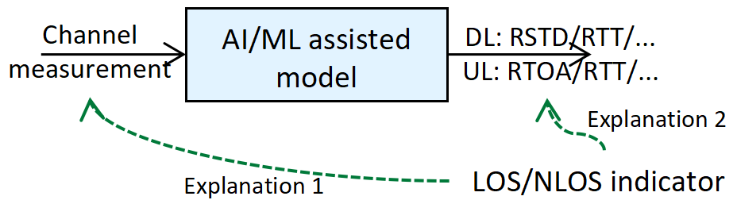
Figure 4 Explanations of LOS/NLOS indicator for cases 2a and 3a
For AI/ML assisted positioning, if the LOS/LOS indicator is reported together with the legacy timing measurement result, the meaning of LOS/NLOS indicator can reuse the current definition. If the LOS/NLOS indicator is reported together with the timing measurement result inference using AI/ML model, the meaning of LOS/NLOS indicator should be revised. Based on the above analysis, we have the following proposals:
Proposal 9: For AI/ML-assisted positioning Case 3a, when the LOS/NLOS indicator is reported together with the legacy timing measurement result, from RAN1 perspective,
- The LOS/NLOS indicator provides the likelihood of a line-of-sight physical propagation path for the channel measured over the resources for which the measurement is reported;
- One LOS/NLOS indicator value is optionally reported from the source to the receiver as in the existing specification.
- The LOS/NLOS indicator can reuse the existing IE LoS/NLoS Information in 38.455.
Proposal 10: For AI/ML-assisted positioning Case 3a, when the LOS/NLOS indicator is reported with the AI/ML model output, from RAN1 perspective,
- The LOS/NLOS indicator provides the likelihood of a line-of-sight virtual path for the model output over the resource for which the measurement is reported.
- The LOS/NLOS indicator can reuse the same format as the existing IE LoS/NLoS Information in 38.455.

Indicator for measurement information
In previous meetings, whether support AI/ML report includes an indicator that indicates the measurement information is derived using AI/ML model. From our perspective, the indicator is not needed, the reasons are as follows.
- The mentioned indicator will not affect LMF’s calculation. For example, in a general TDOA/RTT positioning procedure, LMF will collect the RSTD/RTT measurement information of different TRP pairs, and calculate UE’s location information based on TRPs’ location information and the reported RSTD/RTT. LMF doesn’t care the RSTD/RTT measurement which is derived using AI/ML model or legacy measurement.
- If the LOS/NLOS indicator is associated with the AI/ML model output, i.e., virtual LOS path, the reported LOS/NLOS indicator should always be equal to 1. It can be inferred that the timing information reported with full LOS indications is likely to be inferenced by AI/ML model.
- If the LCM procedure is controlled by LMF, LMF is aware of when the AI/ML is activated or de-activated. LMF can judge whether the measurement information is derived using AI/ML model based on the LCM procedure and the timestamp of each report.
- If AI/ML is a separate positioning method, the model output can be embedded in the new positioning method, there’s no need to introduce an indicator for AI/ML.
Based on the above analysis, we have the following proposal:
Proposal 11: For reporting model output of AI/ML assisted positioning, an indicator identifying whether the measurement is based on AI/ML model is not needed.

Other model output type for AI/ML assisted positioning
For AI/ML assisted positioning, the output of the AI/ML model can be new measurement and/or enhancement of existing measurement, where LOS/NLOS indicator and/or timing information are supported for AI/ML assisted positioning. For UL AI/ML assisted positioning, current positioning methods also support angle measurement reports, LMF can calculate UE’s location information based on reported angle measurement results. Therefore, we have the following proposal:
Proposal 12: The model output of AI/ML assisted positioning can be angle information.
- Other intermediate features in addition to the output listed in TR 38.843 are not precluded.

Model training and model inference

Time stamp
For training data collection, the following agreement concerning TRP’s measurement time stamp was achieved in RAN1#118 for case 3b:
Agreement in RAN1#118:
For training data collection of AI/ML based positioning case 3b, for time stamp of channel measurement,
- For channel measurement generated by TRP/gNB, existing IE “Time Stamp” in TS 38.455 can be reused from RAN1 perspective
Note: Purpose, such as above “training data collection", will not necessarily be specified in RAN 1 specifications
For other cases, the following proposals were listed but no agreement was achieved:
Proposal 4.1.3-1
For AI/ML based positioning Case 3a, regarding the time stamp of channel measurement generated by TRP/gNB, if the channel measurement needs to be reported,
- Existing IE “Time Stamp” in TS 38.455 can be reused from RAN1 perspective.

Proposal 4.1.4-1
For AI/ML based positioning Case 1, if channel measurement and/or label is reported by LMF to UE, both IEs as described in TS 37.355 are included in the time stamp:
- NR-TimeStamp
- UTCTime
  - From RAN1 perspective, UTCTime can be an optional field
  - Note: UTCTime is provided to resolve ambiguity in time stamp. For example, UTCTime is present at least when SFN wraps around.
Note: NR-TimeStamp and UTCTime are intended to refer to the same clock time associated with the label.

Case 1, Case 2a and Case 2b
When the channel measurement is generated by UE, the time stamp issue was discussed but not concluded. In the current measurement report, the time associated with signal measurement information includes the following IEs:
The IE NR-TimeStamp defines the UE measurement associated time stamp.
-- ASN1START

NR-TimeStamp-r16 ::= SEQUENCE {
dl-PRS-ID-r16 INTEGER (0..255),
nr-PhysCellID-r16 NR-PhysCellID-r16 OPTIONAL, -- Need ON
nr-CellGlobalID-r16 NCGI-r15 OPTIONAL, -- Need ON
nr-ARFCN-r16 ARFCN-ValueNR-r15 OPTIONAL, -- Need ON
nr-SFN-r16 INTEGER (0..1023),
nr-Slot-r16 CHOICE {
scs15-r16 INTEGER (0..9),
scs30-r16 INTEGER (0..19),
scs60-r16 INTEGER (0..39),
scs120-r16 INTEGER (0..79)
},
...,
[[
nr-Symbol-r18 INTEGER (0..13) OPTIONAL -- Need ON
]]
}

-- ASN1STOP
The time stamp associated with location information (take TDOA as an example) can be either SFN or UTC time:
-- ASN1START

NR-DL-TDOA-LocationInformation-r16 ::= SEQUENCE {
measurementReferenceTime-r16 CHOICE {
systemFrameNumber-r16 NR-TimeStamp-r16,
utc-time-r16 UTCTime,
...
} OPTIONAL,
...,
[[
locationCoordinates-r17 LocationCoordinates OPTIONAL, -- Cond batch1
locationSource-r17 LocationSource-r13 OPTIONAL -- Cond batch2
]]
}

-- ASN1STOP
For case 1, UE will report the location information to LMF, and the time stamp can reuse the measurement reference time in the current specification, i.e., the time stamp for location information could be either SFN or UTC time. Therefore, we have the following proposal:
Proposal 13: For AI/ML positioning case 1, for the time stamp of location information reported by UE,
- Existing IE “measurementReferenceTime” in TS 37.355 can be reused from RAN1 perspective.
Similarly, for case 2a and case 2b, UE will report the model inference (case 2a) and channel measurement information (case 2b) to LMF, the time stamp can reuse the current time stamp for signal measurement information report. Therefore, we have the following proposals:
Proposal 14: For AI/ML positioning case 2a, for the time stamp of report generated by UE,
- Existing IE “NR-TimeStamp” in TS 37.355 can be reused from RAN1 perspective.
Proposal 15: For AI/ML positioning case 2b, for the time stamp of channel measurement generated by UE,
- Existing IE “NR-TimeStamp” in TS 37.355 can be reused from RAN1 perspective.

In RAN1#119, the following proposal related to the time stamp of label information for case 1 is discussed:
Proposal 4.1.4-1
For AI/ML based positioning Case 1, if channel measurement and/or label is reported by LMF to UE, both IEs as described in TS 37.355 are included in the time stamp:
- NR-TimeStamp
- UTCTime
  - From RAN1 perspective, UTCTime can be an optional field
  - Note: UTCTime is provided to resolve ambiguity in time stamp. For example, UTCTime is present at least when SFN wraps around.
Note: NR-TimeStamp and UTCTime are intended to refer to the same clock time associated with the label.
From our perspective, the current time stamp for location information can be reused, i.e., measurementReferenceTime, where the time includes NR-TimeStamp or UTCTime. Furthermore, a valid duration of the location information could also be included in the time stamp. For example, if the label information refers to a stable UE, the location information is valid for a long time duration. In this case, the UE doesn’t have to request location information from LMF frequently. Based on the above analysis, the following proposal is concluded:
Proposal 16: For AI/ML positioning case 1, for the time stamp of location information sent by LMF, from RAN1 perspective,
- Existing IE “measurementReferenceTime” in TS 37.355 can be reused.
- A valid duration is associated with the “measurementReferenceTime”.

Case 3a
For case 3a, the discussion focuses on whether TRP/gNB will report the channel measurement. In the model training stage, the training data includes the channel measurement and label information. If the training data generation entity is the same as the training entity, the training data generation entity will report the channel measurement and label information to the training entity. In case 3a, the training data generation entity could be TRP/gNB or LMF, and the training entity could be TRP/gNB. If other TRP/gNB provides training data (e.g., via LMF) to the TRP/gNB that trains AI/ML model, the channel measurement is required. But whether a TRP/gNB will take data and labels from other TRPs/gNBs as training data is a separate discussion, the time stamp associated with channel measurement could be discussed further.
From another perspective, for case 3a, the content that will definitely be reported includes the inference output, i.e., timing information generated using AI/ML model. The timing information could be associated with a time stamp. Similar to case 3b, the current IE in TS 38.455 can be reused for case 3a. Therefore, we have the following proposal:
Proposal 17: For AI/ML positioning case 3a, for the time stamp of report generated by TRP/gNB,
- Existing IE “Time Stamp” in TS 38.455 can be reused from RAN1 perspective.

Quality indicator of label
In RAN1#118bis meeting, the quality indicator of the label was discussed, where the indicator provides a reference for the training data’s quality:
Proposal 4.1.5-1A
For training data collection of AI/ML based positioning Cases 1, 3a, 3b, from RAN1 perspective, when label reporting is applicable, quality indicator of label is represented using one of the following options. RAN1 study and select between Option 1 and Option 2.
- Option 1: reuse an existing IE. For each case, proponent companies provide input on the existing IE to use.
- Option 2: define a new IE on UE location quality. Use hard (0 or 1) and soft values (0, 0.1, 0.2, …, 1.0), with value 1 indicating the highest quality.
  - Proponent companies provide information on how to determine the value, entity to generate the label quality, and the applicable signaling.
Among the above options, from our perspective, reusing the current definition requires less effort towards specification design. The specific IE used for indicating the label’s quality depends on the type of label:
- If the label refers to the location information of a UE (case 1 and case 3b), the current IE horizontalUncertainty could be reused. LocationUNC specifies the uncertainty of the location coordinates and comprises horizontalUncertainty and verticalUncertainty. Which is applicable for latitude/longitude and altitude uncertainty. But for AI/ML, the model output only considers the 2D positioning result, vertical uncertainty is not needed for AI/ML positioning.
- If the label refers to the intermediate features inferences by the AI/ML model, the current IEs of different measurements could be reused:
  - If the label is timing information, the format of NR-TimingQuality is applicable for the quality indicator. Quality indicator includes a quality value and a quality resolution (in units of metres), where the quality value provides an estimate of uncertainty.
  - If other intermediate features are supported, the quality indicator can be further studied.
Therefore, we have the following proposal:
Proposal 18: For training data collection of AI/ML based positioning Cases 1, 3a, 3b, from RAN1 perspective, when label reporting is applicable, quality indicator of label is represented reusing an existing IE:
- If the label refers to the location information, horizontalUncertainty is reused.
- If the label refers to the timing information, NR-TimingQuality is reused.
- FFS: other quality indicators if other intermediate features are supported.

Reference signal configuration
As we discussed in RAN1#116 and RAN1#118, current DL PRS and UL SRS are supported for AI/ML based positioning, where SRS configuration can reuse the current configuration procedure.
In the current TS, the reference signal configuration is supported for positioning purposes, and mainly includes the following specifications:
- TS 37.355 (LPP), signaling exchange between UE/PRU and LMF
- TS 38.455 (NRPPa), signaling exchange between gNB and LMF
- TS 38.331, signaling exchange between gNB and UE/PRU
The existing 3GPP specifications have provided comprehensive protocols for positioning, including the reference signal configuration for positioning, where the reference signal can also be used for AI/ML positioning. The detailed configuration, encompassing periodicity, slot offset, number of symbols, repetition factor, and other parameters, is equally applicable to both traditional and AI/ML-based positioning methods. The current reference signal configuration procedures suffice for AI/ML-based positioning, and the parameter values for SRS configuration can also be reused. A similar conclusion can also be achieved for case 3b:
Proposal 19: From RAN1 perspective, for Case 3b measurements,
- The existing procedures can be reused in terms of SRS configuration.
- These measurements can be used for multiple aspects related to case 3b, e.g. training data collection, monitoring, or inference procedures.
- Note: Purpose, such as the training data collection, monitoring, or inference procedures mentioned above, will not necessarily be specified in RAN 1 specifications

For DL AI/ML positioning, the following options were identified as feasible configuration framework for PRS configuration:
Conclusion in RAN1#118bis:
For training data collection of Case 1, in terms of DL PRS configuration for collecting training data, both options are feasible by using legacy mechanisms:
Option A. (UE initiated) UE makes a request to LMF on the preferred DL PRS configuration for training data collection, e.g., on-demand PRS. LMF makes the decision on determining the DL PRS configuration for training data collection and provides the assistance data to the UE.
Option B. (LMF initiated) LMF determines the DL PRS configuration for training data collection and provides the assistance data to the UE.
Note: the UE can be a PRU and/or a Non-PRU UE.
Note: as in existing specification, the DL PRS configurations in the assistance data from LMF to UE are based on DL PRS configuration coordinated between LMF and gNB.
For Option A, UE makes an on-demand PRS request, and sends the request to LMF specifying the desired DL PRS configuration. For AI/ML positioning, the dimension of model input may include the number of TRP, the number of antenna pairs, and the number of sampling points. For example, the model input of the TRP number is 18, but the UE only received DL PRS from 10 TRP, the UE may request 8 more TRP transmit DL PRS for training data collection. However, the activation/de-activation request is not supported in the current on-demand PRS procedure. From this perspective, UE can make on-demand PRS requests indicating the suggested number of TRPs that transmit DL PRS. Therefore, we have the following proposal:
Proposal 20: For option A (UE initialed DL PRS configuration), the following enhancement can be supported:
- On-demand PRS request includes the suggested number of activated TRPs that transmit DL PRS.

Requirements on data collection
If data collection and generation procedures are executed at the same entity, there is no additional specification impact concerning data collection (at least from RAN1 perspective). Otherwise, if data collection and generation procedures are executed at the different entities, the following procedure should be considered. The general procedure of data generation and collection (data collection/generation node can be different entities in different use cases) can be listed as follows (refer to Figure 5):
- Step1: Data collection node indicates the requirement for data collection  - Step2 (UE/PRU/gNB’s behavior): Data generation node generates data based on the configured requirement  - Step3: Data generation node reports the collected data | 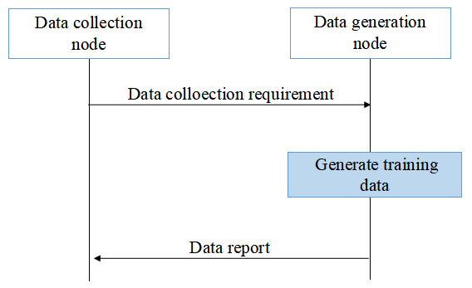  Figure 5 Data generation and collection procedure
It is feasible to let the data collection node configure the data collection requirement for AI/ML positioning model considering the positioning accuracy requirement. More specifically, AI/ML models with higher QoS requirements can collect data with higher quality requirements during the data collection procedure, where the requirements may include quality requirement of the channel measurement, report periodicity, etc. And the data collection/generation entity can be different among use cases. For example, for case 3a, the data collection node is LMF, data generation node is gNB. Therefore, we have the following proposal:
Proposal 21: For AI/ML positioning, different data collection requirements can be configured by the data collection node, where the configuration includes at least:
- Quality requirement of the channel measurement, report periodicity.
Note: The data collection node can be different among different use cases.

Association between part A and part B
In RAN1#117 meeting, the association between part A and part B was discussed, and the following agreement was achieved:
Agreement in RAN1#117:
For training data collection of AI/ML based positioning, if a training data sample contains both Part A and Part B, RAN1 assumes that Part A and Part B in one training data sample are:
- for a same UE (PRU or Non-PRU UE), and
- for a same location associated with Part B.
Note: the association can be discussed
In this subsection, we provide our views on the association between part A and part B.
From training data generation entities’ perspective, the reported data can be Part A + Part B, Part A only, and Part B only. And in previous several meetings, the entities for graining data generation were discussed, where part A and/or part B can be obtained from the same/different entities for different use cases. The specific model training procedure is up to training entities’ implementation, i.e., training entity determines whether the model training is performed using part A + part B or only part A. For example, in case 3b (LMF side model), part A can be provided by a TRP (e.g., using TRP measurement result in TS 37.355), whereas part B can be provided by a PRU (e.g., using ProvideLocationInformation in TS 37.355). After collecting the training data, LMF needs to pair or associate part A with part B. However, how to pair and how to train the model depends on LMF’s implementation. LMF may pair part A and part B based on the associated timestamp, or the ID of PRU as well as the TRP’s measurement report. Among them, the time stamp for TRP channel measurement information are agreed to reuse the current Time Stamp IE in TS 38.455. The time stamp for UE channel measurement report can be discussed later as UE’s measurement reports are related to 2nd priority use cases, i.e., case 2a and case 2b.
It can be observed that most of the training data can be provided by the current structure except Part B for case 3a. In this case, LMF should provide assistance information including ground truth label as well as other association information to gNB. Based on the above analysis, we have the following proposals:
Proposal 22: The association between part A and part B can be determined by the model training entity based on the collected measurement information and label information.
- Part A can be provided by:
  - TRP measurement result in TS 38.455 (case 3a, case 3b).
  - SignalMeasurementInformation in TS 37.355 (case 1, case 2a and case 2b).
- Part B can be provided by:
  - ProvideLocationInformation in TS 37.355 (case 2b, case 3b).
  - ProvideAssistanceData in TS 37.355 (case 1, case 2a).
  - New assistance information sent from LMF to gNB (case 3a).
- Part A and Part B can be associated using:
  - the timestamp provided in measurement and/or location information.
  - UE ID associated with the measurement and/or location information.

Consistency between training and inference
The WID on AI/ML positioning specified the consistency between training and inference regarding NW-side additional conditions (if identified) for inference of UE-side models. And in RAN1#119, the following agreement was achieved:
Agreement in RAN1#119:
For AI/ML based positioning Case 1, all assistance information from legacy UE-based DL-TDOA, other than info #7, can be provided from LMF to UE. For info #7, RAN1 study, if necessary, choose one alternative from the following:
- Alternative 1. Info #7 is provided implicitly via associated ID.
  - Associated ID is signaled by LMF to indicate whether info #7 is consistent between training and inference.
- Alternative 2. Info #7 can be provided either implicitly or explicitly by LMF. Note: no UE capability is introduced on whether info #7 is provided implicitly or explicitly, and the UE can request info #7 to be provided explicitly or implicitly.
  - If provided implicitly, associated ID is signaled by LMF to indicate whether info #7 is consistent between training and inference.
- Alternative 3. Info #7 is not be provided from LMF to UE.
  - If info #7 is not provided, UE may assume info #7 is consistent between training and inference.
- Alternative 4. Info #7 is provided explicitly from LMF to UE.
7 | Geographical coordinates of the TRPs served by the gNB (include a transmission reference location for each DL-PRS Resource ID, reference location for the transmitting antenna of the reference TRP, relative locations for transmitting antennas of other TRPs)

For TRP’s location, there’s a discussion on whether/how to provide the location information to UE. From our perspective, the location information can be provided to UE as the legacy way, i.e., the geographical coordinates of the TRPs are provided to UE explicitly, and this field is optional. UE can evaluate the consistency between training and inference based on the provided TRP location (if provided) or based on the validity area information (if the TRP location is not provided). Furthermore, the definition of associated ID requires a significant impact on the specification, and there are several aspects to be determined for associated ID:
- The associated ID update granularity, i.e., location change threshold that causes associated ID change. It’s difficult to define a specific TRP location change threshold for UE, i.e., hard to say whether 1cm/0.1m TRP’s location update will cause training and inference inconsistency. Furthermore, the threshold that causes changes in training inference consistency may vary for different UEs, so it’s difficult to define the associated ID for each UE.
- The level of associated ID, i.e., the associated ID is defined in TRP-level, cell-level or area-level. For TRP-level or cell-level associated ID, a UE may receive multiple associated IDs as UE would receive DL PRS from multiple TRPs, where the TRPs could be from different cells, and LMF should configure multiple associated IDs for different TRPs/cells for different UEs. For area-level associated ID, the associated ID should consider the location information of all the TRPs within the area. All of those cause a lot of associated ID assignment and configuration efforts
- The manifestation of associated ID, i.e., the associated ID is represented (1) using different integer values indicating different location information or (2) using Boolean values to indicate whether there’s a change in the location information. For (1), if any position change of each TRP will result in an update of the associated ID, then it may require a lot of IDs to represent all TRPs’ location combinations. For (2), it’s difficult for LMF/TRP to judge whether the location change will affect the UE side consistency issue. For example, an indoor positioning system is deployed in factory #1, wherein multiple TRPs are deployed with a given layout. In another test occasion, the positioning system in factory #1 is moved into factory #2, and the TRPs locations are updated, while the whole positioning layout remains unchanged. In this case, there’s an update on TRPs’ location, but the consistency of training and inference remains unchanged.
In the last meeting, there was a discussion on whether assistance data from DL-AOD can be provided for AI/ML positioning. From our perspective, in AI/ML, all of the assistance information supported in the legacy positioning procedure can be supported to ensure the consistency between training and inference.
Based on the above analysis, we have the following proposal:
Proposal 23: For AI/ML based positioning Case 1, all assistance information from legacy UE-based DL-TDOA can be provided from LMF to UE explicitly.
- There is no need to introduce associated ID for AI/ML positioning.
Proposal 24: For AI/ML based positioning Case 1, all assistance information from legacy UE-based DL-AOD can be provided from LMF to UE.

Model monitoring

Label-free monitoring
Model monitoring refers to a procedure that monitors the inference performance of the AI/ML model. For AI/ML positioning, model monitoring based on model output should be prioritized as the model output can reflect the positioning performance more intuitively. Furthermore, label-free monitoring requires more statistical features, it’s up to implementation for the model residency to perform label-free monitoring. Therefore, we have the following proposal, which could be treated as a conclusion:
Proposal 25: Label-free monitoring can be realized by implementation in a manner transparent to specification. No further discussion on label-free monitoring.

Model monitoring metric calculation

Case 1
For model performance monitoring of AI/ML positioning case 1, the following agreement and conclusion was achieved:
Agreement in RAN1#116bis:
For model performance monitoring of AI/ML positioning Case 1, for model performance monitoring metric calculation in label-based model monitoring, study the feasibility, benefits, and potential specification impact of the following options with regard to how to generate information on ground truth label:
- Option A. The target UE side performs monitoring metric calculation.
  - Option A-1. At least information on ground truth label of the target UE is generated by LMF and provided to the target UE.
    - In one example, target UE and/or gNB sends measurement (e.g., legacy measurement) to LMF so that LMF can derive the information on ground truth label.
  - Option A-2. At least position calculation assistance data (e.g., existing information for UE-based positioning method) is provided from LMF to the target UE.
  - Option A-3. Reuse Rel-18 assistance data transfer framework from LMF to the target UE, where the PRU measurement (e.g., legacy measurement) and the corresponding PRU location are sent via LMF to the target UE.
  - Option A-4. PRU measurement (and the corresponding PRU location if not already known at the UE-side) are sent from PRU to the target UE side (e.g., target UE, OTT server).
    - Note: Option A-4 can be realized by implementation in a manner transparent to specification if the PRU sends information to the target UE side in a proprietary method.
- Option B. The LMF performs monitoring metric calculation.
  - Option B-1. at least inference result (i.e., the model output corresponding to target UE’s channel measurement) of the target UE is sent by the target UE to LMF.
  - Option B-2. PRU’s channel measurement is sent via LMF to the target UE, and the inference result (i.e., the model output corresponding to PRU’s channel measurement) is sent by the target UE to LMF.
Note: exact method to perform the monitoring metric calculation is up to implementation.
Note: Other options are not precluded.

Conclusion in RAN1#118:
For model performance monitoring of AI/ML positioning Case 1, for model performance monitoring metric calculation in label-based model monitoring,
- Option A-4 can be realized by implementation in a manner transparent to specification specification if the PRU sends information to the target UE side in a proprietary method. No further discussion on Option A-4.

Agreement in RAN1#119:
For model performance monitoring of AI/ML positioning Case 1, support at least:
- Option A. The target UE side performs monitoring metric calculation.
  - The target UE may signal the monitoring outcome to the LMF.
  - FFS: content of monitoring outcome
- FFS: Option B
For UE-side model, the model monitoring procedure can be located in LMF or UE:
- If performance monitoring metric calculation is executed on UE side (option A), the following specification impacts should be considered:
- Option A-1: LMF provides the location information of the UE to the target UE side.
- Option A-2: LMF provides the assistance data to the target UE side.
- Option A-3: LMF provides the measurement information of PRU to the target UE side.
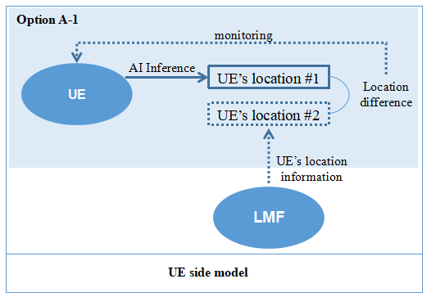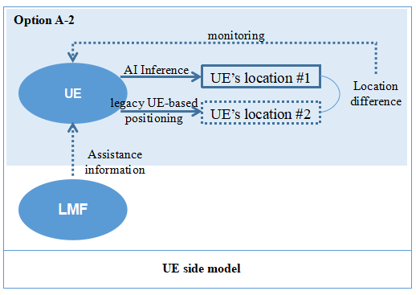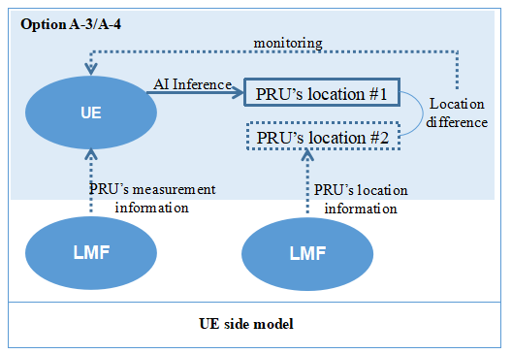
Figure 6 UE performs monitoring metric calculation
- If performance monitoring metric calculation is executed on LMF (option B), similar to the monitoring procedure for LMF side model, UE/PRU’s location information from LMF or legacy positioning results can be used as ground truth label for model monitoring. The following specification impacts should be considered for each option:
- Option B-1: UE reports the inference result to LMF.
- Option B-2: LMF provides the measurement information of PRU to the target UE side, and UE reports the inference result to LMF.
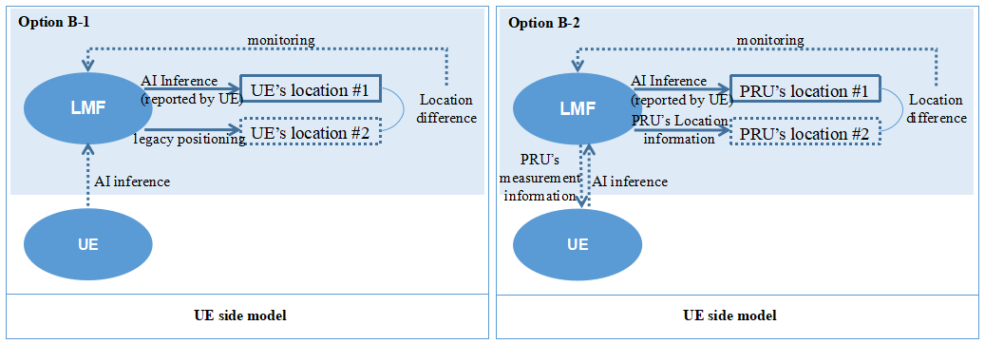
Figure 7 UE performs monitoring metric calculation
As shown in Figure 6 and Figure 7, UE/LMF may compare the difference between AI/ML positioning results and collected ground truth labels for AI/ML model monitoring, where the detailed monitoring methods are up to UE/LMF’s implementation. In RAN1#119, option A is supported, where UE performs monitoring metric calculation. With this option, additional UE processing/monitoring capability is required and, different UEs may have different monitoring metrics, the model monitoring criterion may not be unified, leading to unpredictable positioning accuracy degradation. As a supplementary monitoring method, LMF could perform monitoring metric calculation for case 1.
Therefore, we have the following proposal:
Proposal 26: For model performance monitoring of AI/ML positioning Case 1, for model performance monitoring metric calculation in label-based model monitoring, support option B-1 and option B-2:
- Option B-1. at least inference result (i.e., the model output corresponding to target UE’s channel measurement) of the target UE is sent by the target UE to LMF.
- Option B-2. PRU’s channel measurement is sent via LMF to the target UE, and the inference result (i.e., the model output corresponding to PRU’s channel measurement) is sent by the target UE to LMF.

For option A, there’s an FFS on the content of the monitoring outcome and details on when/what to report the monitoring outcome should be discussed. The content of the monitoring outcome includes the suggested monitoring behavior or positioning accuracy. And for the time when UE reports monitoring outcome, the following outcome reporting methods could be considered:
Option 1: Up to UE’s implementation, i.e., UE reports the monitoring outcome whenever UE wants.
Option 2: UE reports the monitoring outcome when there’s a need to change the current behavior.
Option 3: LMF pre-configures criterion on when UE should report monitoring outcome.
Option 4: LMF sends request to trigger UE’s monitoring outcome report.
Option 5: LMF configures the reporting amount and reporting interval to UE for monitoring outcome report.
All of the above reporting occasions could be considered, and in the following meetings, we can make further down-selection. For model performance monitoring of case 1, we have the following proposals:
Proposal 27: For model performance monitoring of AI/ML positioning Case 1, support UE report suggested monitoring behavior and/or positioning accuracy as monitoring outcome to LMF.
Proposal 28: For model performance monitoring of AI/ML positioning Case 1, choose one or more options from the following for the time when UE reports monitoring outcome to LMF:
- Option 1: Up to UE’s implementation, i.e., UE reports the monitoring outcome whenever UE wants.
- Option 2: UE reports the monitoring outcome when there’s a need to change the current behavior.
- Option 3: LMF pre-configures criterion on when UE should report monitoring outcome.
- Option 4: LMF sends request to trigger UE’s monitoring outcome report.
- Option 5: LMF configures the reporting amount and reporting interval to UE for monitoring outcome report.

Case 3a
For AI/ML assisted positioning, the output of the AI/ML model can be intermediate features. And RAN1 already agreed that the exact method to perform monitoring metric calculation is up to implementation:
Agreement in RAN1#118:
For AI/ML positioning Case 3a, for performance monitoring metric calculation in label-based monitoring, from RAN1 perspective, Option A and Option B are feasible,
- Option A. NG-RAN node performs monitoring metric calculation for its own model.
- Option B. LMF performs monitoring metric calculation for the model located at the NG-RAN node.
Note: Final selection of Option A and Option B is out of RAN1 scope. Potential support of Option A and/or Option B is pending RAN3 confirmation.
Note: Exact method to perform monitoring metric calculation is up to implementation.
Note: For Option A, RAN1 assumes that user data privacy needs to be preservedIn general, there are two ways to derive the monitoring metric:
In the last RAN3 meeting, the following working assumptions toward case 3a model monitoring metric calculation:
WA: RAN3 will proceed with Option A: NG-RAN node performs monitoring metric calculation for its own model.
Therefore, for case 3a, it can be concluded that the monitoring metric calculation is up to NG-RAN node’s implementation, wherein NG-RAN node should be responsible for analyzing the difference between ground truth label and inference output.
There are two alternatives for NG-RAN node to get the ground truth label for model monitoring metric calculation:
- Alt 1: NG-RAN node performs legacy measurement, which can be used as ground truth label for model monitoring. There’s no specification impact.
- Alt 2: NG-RAN node requests LMF to provide the ground truth label for its model. LMF needs to provide assistance data to NG-RAN node for monitoring metric calculation.
It should be noted that legacy measurement could be not accurate enough to act as the ground truth label for model monitoring, especially in heavy NLOS conditions. Therefore, to improve the monitoring performance, Alt 2 should be supported for case 3a. And we have the following proposal:
Proposal 29: For case 3a, LMF provides assistance data on the ground truth label to TRP. FFS: the detailed IE.

Case 3b
In case 3b, the model monitoring procedure should be located in LMF, it is suggested to analyse the necessity of assistance information and/or measurement report required for model monitoring. From our perspective, the details on assistance information and/or measurement reports rely on whether LMF has the ground truth label for model monitoring. There are two alternatives for LMF to get the ground truth label for model monitoring metric calculation (the assistance information and/or measurement report required for these two alternatives can be different):
- Alt 1: LMF may have some location information of UE/PRU, which can be used as ground truth label for model monitoring.
- Alt 2: LMF request UE to report legacy positioning result as ground truth label for model monitoring. It should be noted that some UE-based legacy positioning results (e.g., DL-TDOA, DL-AOD, etc.) are not accurate enough to act as the ground truth label for model monitoring, especially in heavy NLOS conditions. Instead, the RAT-independent positioning results with higher positioning accuracy should be considered, such as GNSS information (for outdoor scenario, if applicable) or UWB positioning result (for indoor scenario, if applicable. It should be noted that UWB positioning result is out of 3GPP’s scope).
As shown in Figure 8, LMF may compare the difference between AI/ML positioning results and collected ground truth labels for AI/ML model monitoring. Detailed monitoring methods are up to LMF’s implementation. For LMF-side model monitoring, we have the following proposal:
Proposal 30: For LMF-side model, whether assistance information is required for model monitoring depends on whether LMF has prior information on UE/PRU’s location:
- If LMF has prior information on UE/PRU’s location, there’s no need to let UE/PRU/gNB send any assistance information.
- If LMF doesn’t have prior information on UE/PRU’s location, LMF can request UE to report legacy positioning result as ground truth label for model monitoring.
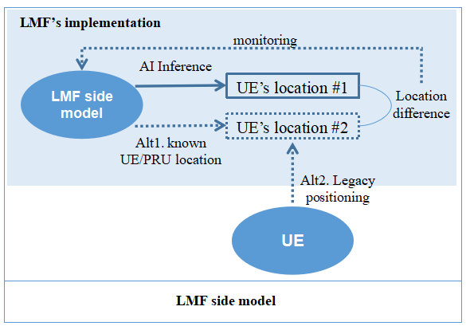
Figure 8 Model monitoring for LMF-side model

Entities for model monitoring
In AI/ML based positioning process, model monitoring may include different functions, i.e., model inference, monitoring metric calculation and making monitoring decisions. These different functions can be located in the same or different entities. The following table lists all possible entities for different model monitoring functions, our preference is let LMF calculate the model monitoring metric for UE side model and let gNB calculate model monitoring metric for gNB side model.
Table 3 Entities for model monitoring in different model types
Model type | Model inference entity | Model monitoring metric calculation entity | Model monitoring entity (make monitoring decision)
UE side model | UE | UE/LMF | UE/LMF
NG-RAN side model | gNB | gNB/LMF | gNB/LMF
LMF | LMF | LMF | LMF
Take NG-RAN side model as an example, as shown in the following figure, there are four different ways for model monitoring, i.e., gNB performs model monitoring metric calculation and makes monitoring decision, LMF performs model monitoring metric calculation and makes monitoring decision, LMF performs model monitoring metric calculation and gNB makes monitoring decision, and gNB performs model monitoring metric calculation and LMF makes monitoring decision.
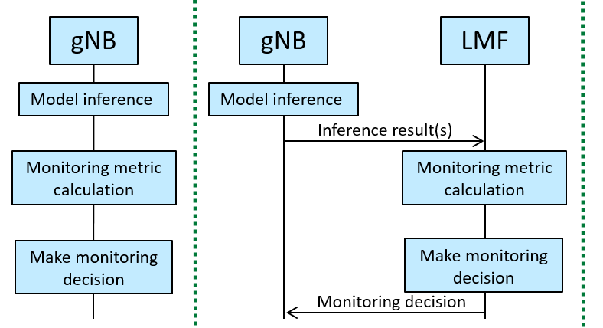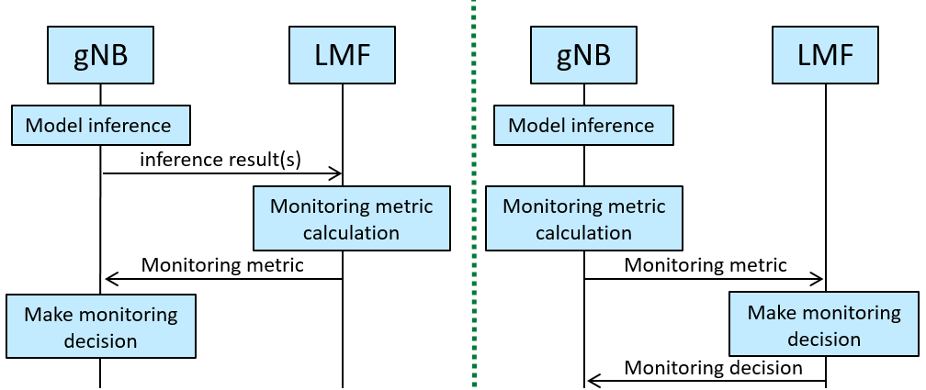
Figure 9 Model monitoring examples for NG-RAN side model
Based on the above analysis, we have the following proposal:
Proposal 31: For UE side model and NG-RAN side model, model monitoring metric calculation function and model monitoring function can be located in the same or different entities.

UE capability reporting
In RAN2, the following agreement was achieved:
Agreement in LCM for AI positioning:
- The following procedures for LCM for UE sided model for AI positioning case 1 is the baseline:
  - Step 1: LMF may request the UE to report the supported functionalities at the UE side by LPP request capabilities message.
  - Step 2: UE sends LPP provide capabilities message to LMF with the supported functionalities at the UE side.
  - Step 3: LMF sends the LPP provide assistance data message (which may contain network side additional condition).
  - Step 4: UE reports the applicable functionality to the LMF by the LPP provide capabilities message.
  - Step 5: The LMF requests the inferred location information using the LPP request location information message.
  - Step 6: UE reports the inferred location using LPP provide location information message.
- Whether the inference configuration is provided in step 3 or/and step 5 is FFS (to be revised based on RAN1 progress).
- Whether network side additional condition is needed and what it contains is FFS (to be revised based on RAN1 progress).
- FFS whether LMF controls the UE sending unsolicited LPP provide capabilities (i.e. whether step4 is sent reactively or proactively). FFS the signalling details.
It was specified that UE sends LPP provide capabilities message to LMF, which may include functionality-level UE capability information. For positioning, the functionality can be recognized per use case, and for each use case/functionality, there can be multiple AI/ML models. For UE-side model, functionality is associated with each use case, i.e., UE may report capability for each use case. Therefore, we have the following proposal:
Proposal 32: For AI/ML positioning, functionality is recognized as use case 1, use case 2a and use case 2b, where UE capability is reported per use case. FFS: detailed parameters for UE capability.

Conclusion
In this contribution, we have the following observations and proposals with regard to AI/ML positioning.
Model input
Proposal 1: The following candidate values for Nt' and k are supported:
- The set of candidate values for N_{t}' include at least: 9, 16, 24.
- The set of candidate values for k include at least: 0…5.
Proposal 2: Do not support gNB report offset to LMF in AI/ML positioning case 3b.
Proposal 3: For Rel-19 AI/ML based positioning, for Case 2b, in addition to path-based measurement that is referring to the measurement in the existing specifications (up to Rel-18), additionally support the following enhancement to the measurement,
- The measurement is composed of N_{t}' values of the estimated channel response in time domain. The N_{t}’ values are selected from a list of N_{t} consecutive channel response values, which have timing granularity T.
- The timing information for the N_{t}' values are reported with a timing granularity T, where T=2^{k}xT_{c}. k represents the timing reporting granularity factor. T_{c} is the basic time unit for NR.
  - The associated measurement (e.g., power if reported) corresponds to the measurement for the reported N_{t}' values.
- The timing information is defined relative to a reference time, same as the path-based measurement.
- The starting time of the list of N_{t} consecutive values is determined as: starting time = first detected path rounded down with timing granularity T.
- LMF can signal parameter values of N_{t}, N_{t}', k to UE via LPP. FFS: Candidate set values.
  - The UE may use different N_{t}', N_{t} and/or k values other than the signalled parameter for measurement reporting. In this case, it’s up to LMF implementation to process the reported measurement.
Note: the purpose of the time domain channel measurements, such as for Rel-19 AI/ML based positioning, is not specified
Proposal 4: There’s no need to introduce power quality for channel measurement.
Proposal 5: For training data collection of AI/ML based positioning, the quality indicator of timing information in Part A is associated with the whole channel measurement.
Proposal 6: For AI/ML based positioning case 2b, for UE channel measurement reported to LMF, reuse the reference time of current DL RSTD and/or UE Rx-Tx time difference, the following options can be considered:
- Option 1 (1st priority): The reference time is T_{SubframeRxi}, as defined in TS 38.215, clause 5.1.29.
- Option 2 (2nd priority): The reference time is T_{UE-TX}, as defined in TS 38.215, clause 5.1.30.
Observation 1: The positioning performance of CIR based model input is better than PDP based model input, which shows that path phase information is beneficial for AI/ML based positioning, while the signalling overhead of CIR is slightly higher than that of PDP. Exemplary results are:
- For single port evaluation with N't =64, the positioning error of PDP based positioning is about 1.20 times that of CIR based positioning, the overhead of CIR is about 1.89 times that of PDP;
- For single port evaluation with N't=128, the positioning error of PDP based positioning is about 1.60 times that of CIR base positioning, the overhead of CIR is about 1.94 times that of PDP;
- For multi-port evaluation with N't=256, the positioning error of PDP based positioning is about 2.21 times that of CIR base positioning, the overhead of CIR is about 1.98 times that of PDP.
Observation 2: Compared with PDP, CIR may provide better positioning performance when the signalling overheads of CIR and PDP are the same.
Proposal 7: In AI/ML based positioning, phase information is used for determining model input.
Observation 3: For power measurement, the positioning performance of case 2 is slightly better than case 1 (6.67% performance gain), while the signalling overhead of case 2 is twice that of case 1.
Proposal 8: The mapping table of RSRPP in TS 38.133 can be reused for AI/ML positioning.
Model output
Proposal 9: For AI/ML-assisted positioning Case 3a, when the LOS/NLOS indicator is reported together with the legacy timing measurement result, from RAN1 perspective,
- The LOS/NLOS indicator provides the likelihood of a line-of-sight physical propagation path for the channel measured over the resources for which the measurement is reported;
- One LOS/NLOS indicator value is optionally reported from the source to the receiver as in the existing specification.
- The LOS/NLOS indicator can reuse the existing IE LoS/NLoS Information in 38.455.
Proposal 10: For AI/ML-assisted positioning Case 3a, when the LOS/NLOS indicator is reported with the AI/ML model output, from RAN1 perspective,
- The LOS/NLOS indicator provides the likelihood of a line-of-sight virtual path for the model output over the resource for which the measurement is reported.
- The LOS/NLOS indicator can reuse the same format as the existing IE LoS/NLoS Information in 38.455.
Proposal 11: For reporting model output of AI/ML assisted positioning, an indicator identifying whether the measurement is based on AI/ML model is not needed.
Proposal 12: The model output of AI/ML assisted positioning can be angle information.
- Other intermediate features in addition to the output listed in TR 38.843 are not precluded.
Model training and model inference
Proposal 13: For AI/ML positioning case 1, for the time stamp of location information reported by UE,
- Existing IE “measurementReferenceTime” in TS 37.355 can be reused from RAN1 perspective.
Proposal 14: For AI/ML positioning case 2a, for the time stamp of report generated by UE,
- Existing IE “NR-TimeStamp” in TS 37.355 can be reused from RAN1 perspective.
Proposal 15: For AI/ML positioning case 2b, for the time stamp of channel measurement generated by UE,
- Existing IE “NR-TimeStamp” in TS 37.355 can be reused from RAN1 perspective.
Proposal 16: For AI/ML positioning case 1, for the time stamp of location information sent by LMF, from RAN1 perspective,
- Existing IE “measurementReferenceTime” in TS 37.355 can be reused.
- A valid duration is associated with the “measurementReferenceTime”.
Proposal 17: For AI/ML positioning case 3a, for the time stamp of report generated by TRP/gNB,
- Existing IE “Time Stamp” in TS 38.455 can be reused from RAN1 perspective.
Proposal 18: For training data collection of AI/ML based positioning Cases 1, 3a, 3b, from RAN1 perspective, when label reporting is applicable, quality indicator of label is represented reusing an existing IE:
- If the label refers to the location information, horizontalUncertainty is reused.
- If the label refers to the timing information, NR-TimingQuality is reused.
- FFS: other quality indicators if other intermediate features are supported.
Proposal 19: From RAN1 perspective, for Case 3b measurements,
- The existing procedures can be reused in terms of SRS configuration.
- These measurements can be used for multiple aspects related to case 3b, e.g. training data collection, monitoring, or inference procedures.
- Note: Purpose, such as the training data collection, monitoring, or inference procedures mentioned above, will not necessarily be specified in RAN 1 specifications
Proposal 20: For option A (UE initialed DL PRS configuration), the following enhancement can be supported:
- On-demand PRS request includes the suggested number of activated TRPs that transmit DL PRS.
Proposal 21: For AI/ML positioning, different data collection requirements can be configured by the data collection node, where the configuration includes at least:
- Quality requirement of the channel measurement, report periodicity.
Note: The data collection node can be different among different use cases.
Proposal 22: The association between part A and part B can be determined by the model training entity based on the collected measurement information and label information.
- Part A can be provided by:
  - TRP measurement result in TS 38.455 (case 3a, case 3b).
  - SignalMeasurementInformation in TS 37.355 (case 1, case 2a and case 2b).
- Part B can be provided by:
  - ProvideLocationInformation in TS 37.355 (case 2b, case 3b).
  - ProvideAssistanceData in TS 37.355 (case 1, case 2a).
  - New assistance information sent from LMF to gNB (case 3a).
- Part A and Part B can be associated using:
  - the timestamp provided in measurement and/or location information.
  - UE ID associated with the measurement and/or location information.
Consistency between training and inference
Proposal 23: For AI/ML based positioning Case 1, all assistance information from legacy UE-based DL-TDOA can be provided from LMF to UE explicitly.
- There is no need to introduce associated ID for AI/ML positioning.
Proposal 24: For AI/ML based positioning Case 1, all assistance information from legacy UE-based DL-AOD can be provided from LMF to UE.
Model monitoring
Proposal 25: Label-free monitoring can be realized by implementation in a manner transparent to specification. No further discussion on label-free monitoring.
Proposal 26: For model performance monitoring of AI/ML positioning Case 1, for model performance monitoring metric calculation in label-based model monitoring, support option B-1 and option B-2:
- Option B-1. at least inference result (i.e., the model output corresponding to target UE’s channel measurement) of the target UE is sent by the target UE to LMF.
- Option B-2. PRU’s channel measurement is sent via LMF to the target UE, and the inference result (i.e., the model output corresponding to PRU’s channel measurement) is sent by the target UE to LMF.
Proposal 27: For model performance monitoring of AI/ML positioning Case 1, support UE report suggested monitoring behavior and/or positioning accuracy as monitoring outcome to LMF.
Proposal 28: For model performance monitoring of AI/ML positioning Case 1, choose one or more options from the following for the time when UE reports monitoring outcome to LMF:
- Option 1: Up to UE’s implementation, i.e., UE reports the monitoring outcome whenever UE wants.
- Option 2: UE reports the monitoring outcome when there’s a need to change the current behavior.
- Option 3: LMF pre-configures criterion on when UE should report monitoring outcome.
- Option 4: LMF sends request to trigger UE’s monitoring outcome report.
- Option 5: LMF configures the reporting amount and reporting interval to UE for monitoring outcome report.
Proposal 29: For case 3a, LMF provides assistance data on the ground truth label to TRP. FFS: the detailed IE.
Proposal 30: For LMF-side model, whether assistance information is required for model monitoring depends on whether LMF has prior information on UE/PRU’s location:
- If LMF has prior information on UE/PRU’s location, there’s no need to let UE/PRU/gNB send any assistance information.
- If LMF doesn’t have prior information on UE/PRU’s location, LMF can request UE to report legacy positioning result as ground truth label for model monitoring.
Proposal 31: For UE side model and NG-RAN side model, model monitoring metric calculation function and model monitoring function can be located in the same or different entities.
UE capability reporting
Proposal 32: For AI/ML positioning, functionality is recognized as use case 1, use case 2a and use case 2b, where UE capability is reported per use case. FFS: detailed parameters for UE capability.

Reference
- Draft Report of 3GPP TSG RAN WG1#119
- R1-2410921, Final summary of specification support for positioning accuracy enhancement, Moderator (Ericsson)
- R1-2306799, Evaluation on AI for positioning enhancement, ZTE.

